Vegan Chocolate Vending Machine

Unit Test (Java)

Developer: Edgar Francis A. Felix

Date: 4/14/2019

|  |  |  |  |
| --- | --- | --- | --- |
| **Item #** | **Description** | **Status** | **Comments** |
| 1 | Heading information: | Pass |  |
| 1.1 | title is shown. | Pass |  |
| 1.2 | menu items are listed. | Pass |  |
| 1.3 | accepted coins are listed. | Pass |  |
| 1.4 | “Cancel” input is shown. | Pass |  |
| 1.5 | format of box and text are in correct. | Pass |  |
| 2 | Inserted valid coins: | Pass |  |
| 2.1 | total coins inserted is shown. | Pass |  |
| 2.2 | accepts all valid coins and adds them to the total coins correctly. | Pass |  |
| 2.3 | a new prompt is shown after entering a value. | Pass |  |
| 3 | Inserted 5C coins: | Pass |  |
| 3.1 | user is informed that its not accepted by the machine. | Pass |  |
| 3.2 | 5C coin is returned. | Pass |  |
| 3.3 | list of valid coins are displayed. | Pass |  |
| 3.4 | total coins did not change. | Pass |  |
| 3.5 | all notification are properly aligned and indented. | Pass |  |
| 4 | Invalid inputs: | Pass |  |
| 4.1 | user is informed that input is not valid. | Pass |  |
| 4.2 | invalid coin is returned. | Pass |  |
| 4.3 | list of valid coins are displayed. | Pass |  |
| 4.4 | total coins did not change. | Pass |  |
| 4.5 | all notification are properly aligned and indented. | Pass |  |
| 5 | Total coins inserted is equals or greater than the price of a menu item: | Pass |  |
| 5.1 | menu item is listed. | Pass |  |
| 5.2 | total coins is still less than the highest priced item, the machine should also say that they may still enter coins. | Pass |  |
| 6 | The user selects a menu item and the total inserted coins are exactly the same as the selected item price: | Pass |  |
| 6.1 | correct item is dispensed. | Pass |  |
| 6.2 | exit message is displayed. | Pass |  |
| 6.3 | a new transaction is initiated showing the heading and prompt. | Pass |  |
| 7 | The user selects a menu item and the total inserted coins are greater than the selected item price: | Pass |  |
| 7.1 | if the correct item is dispensed. | Pass |  |
| 7.2 | if the correct change is dispensed. | Pass |  |
| 7.3 | if the exit message is displayed. | Pass |  |
| 7.4 | if a new transaction is initiated showing the heading and prompt. | Pass |  |
| 8 | The user selects a menu item and the total inserted coins are less than the selected item price: | Pass |  |
| 8.1 | machine says that the snack is not yet available and asks for more coins to be inserted. | Pass |  |
| 8.2 | menu items that can be purchased with the inserted coins are listed. | Pass |  |
| 9 | The user cancels the transaction: | Pass |  |
| 9.1 | unused coins are dispensed. | Pass |  |
| 9.2 | exit message is displayed. | Pass |  |
| 9.3 | a new transaction is initiated showing the heading and prompt. | Pass |  |
| 10 | The application is terminated: | Pass |  |
| 10.1 | unused coins are dispensed. | Pass |  |
| 10.2 | exit message is displayed. | Pass |  |
| 10.3 | application is terminated. | Pass |  |

## Item # 1: Heading information.

Step 1: In the CLI, go to directory where the application resides then execute the application by typing “java VeganChocoVendo”.

Step 2: The application will immediately show the heading information. Check the contents of the heading.

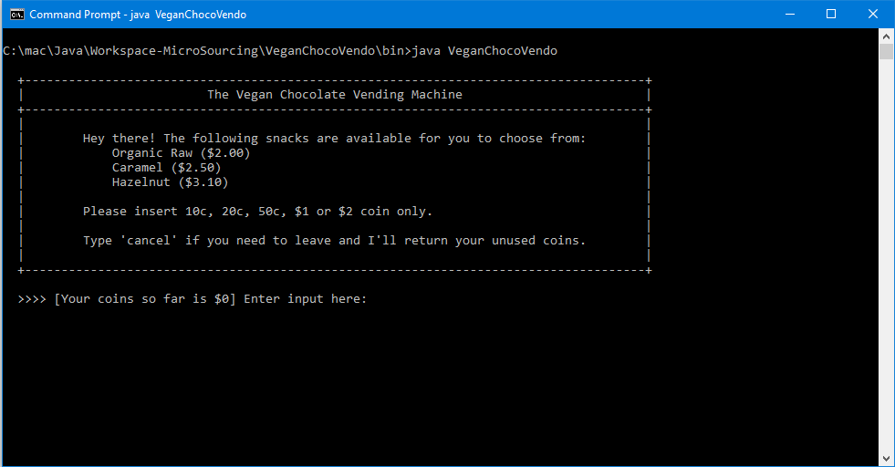

Result:

1.1 - The title is shown correctly.

1.2 - Menu items are complete. The names and prices are correct.

1.3 - The accepted coins are listed correctly.

1.4 - The ‘cancel’ command is shown and described appropriately.

1.5 - The surrounding box is in order and appropriate spacing is observed for padding and margin.

## Item # 2: Inserted valid coins.

Step 1: In the user input prompt, enter the value “10c”, “20c”, “50c”, “$1”, “$2” sequentially.

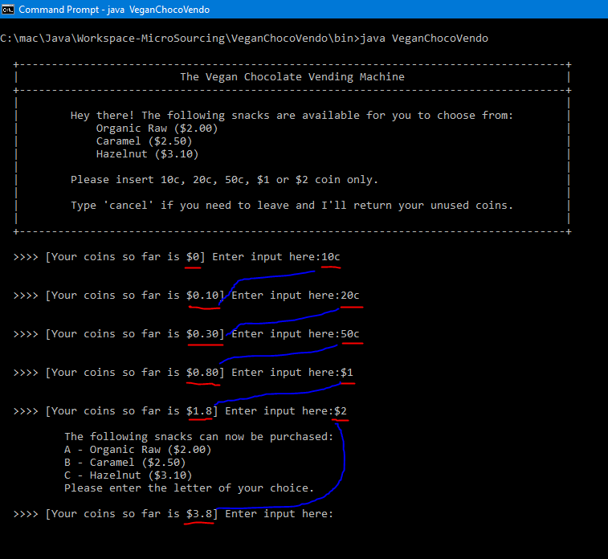

Result:

2.1 - The total coins is shown.

2.2 - All valid coins are correctly captured and added to the total coins correctly.

2.3 - A new promt is shown after every input entry.

## Item # 3: Inserted 5C coins.

Step 1: Enter “5C”.

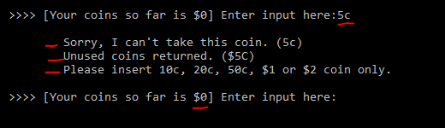

Result:

3.1 - The user is informed that 5c coin is not valid.

3.2 - The 5c coin is returned.

3.3 - The list of valid coins are displayed.

3.4 - The total coins did not change.

3.5 - All notifications from machine are aligned and indented correctly.

## Item # 4: Invalid inputs.

Step 1: Enter “asdf”.

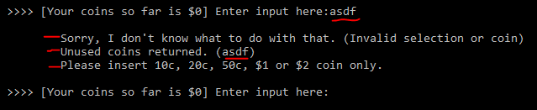

Result:

4.1 - The user is informed that the input is not valid.

4.2 - The coin is returned.

4.3 - The list of valid coins are displayed.

4.4 - The total coin did not change.

4.5 - All notifications from machine are aligned and indented correctly.

## Item # 5: Total coins inserted is equals or greater than the price of a menu item, the menu item should be displayed as available for purchase.

Step 1: Enter “cancel” to make sure the total coins is zero.

Step 2: Enter “$2”.

Step 3: Enter “50c”.

Step 4: Enter “50c” then “10c”.

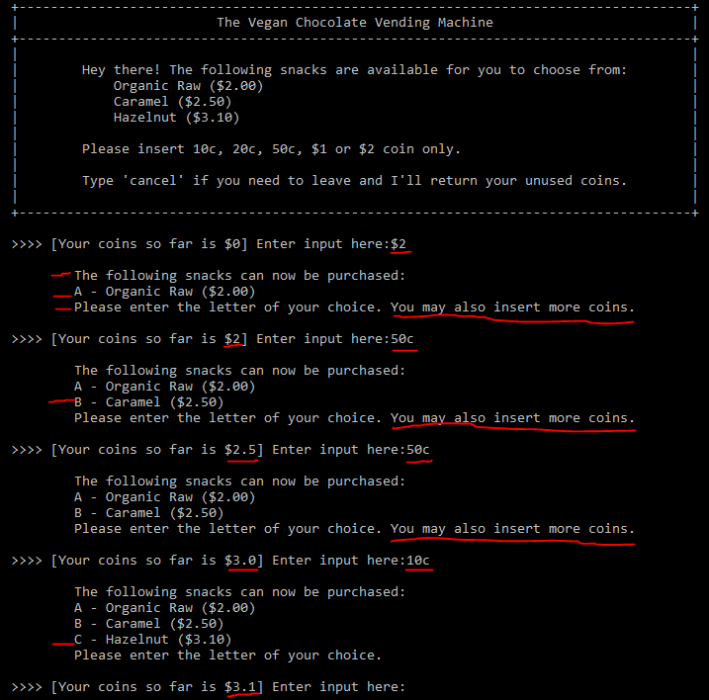

Result:

5.1 - Menu items are shown when there is enough coins to purchase the item.

5.2 - When coins is still not enough for the highest priced item, the prompt says that the user can enter more coins. When the coins are enough to buy the highest priced item, it is no longer mentioned since all unused coins will be returned after every transaction.

## Item # 6: User selects a menu item and the total inserted coins are exactly the same as the selected item price.

Step 1: Enter “cancel” to clear total coins.

Step 2: Enter “$2”.

Step 3: Enter “a” to select “Organic Raw” menu item.

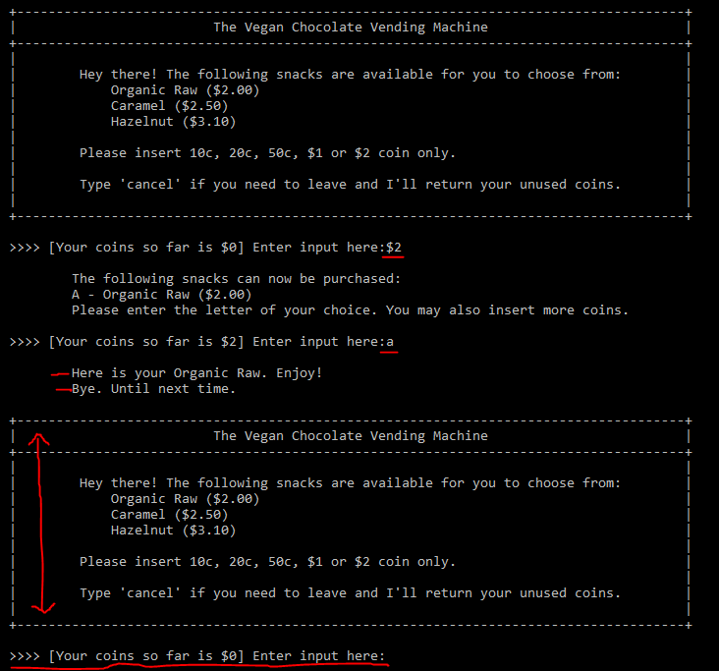

Step 4: Enter “$2” then “50c”.

Step 5: Enter “b” to select “Caramel” menu item.

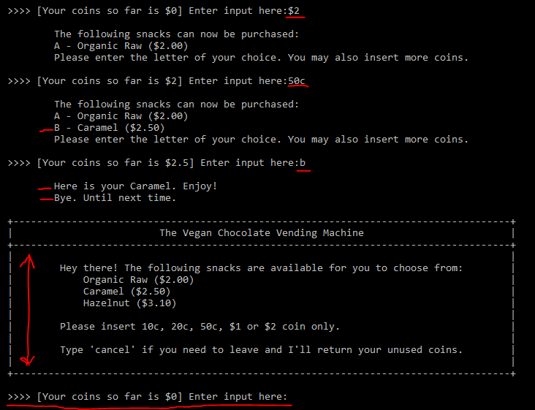

Step 6: Enter “$2” then “$1” then “10c”.

Step 7: Enter “c” to select “Hazelnut” menu item.

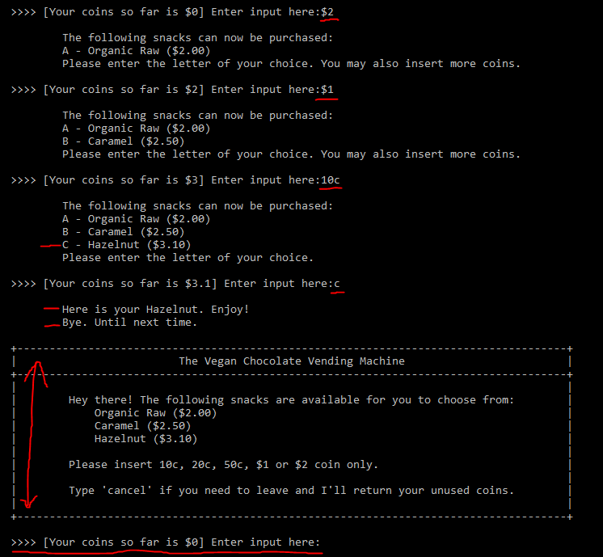

Result:

6.1 - The correct item is dispensed.

6.2 - The exit message is displayed.

6.3 - A new transaction is initiated. The heading and prompt with zero coins are displayed.

## Item # 7: User selects a menu item and the total inserted coins are greater than the selected item price.

Step 1: Enter “cancel” to clear total coins.

Step 2: Enter “$2” and “10c”.

Step 3: Enter “a” to select “Organic Raw” menu item.

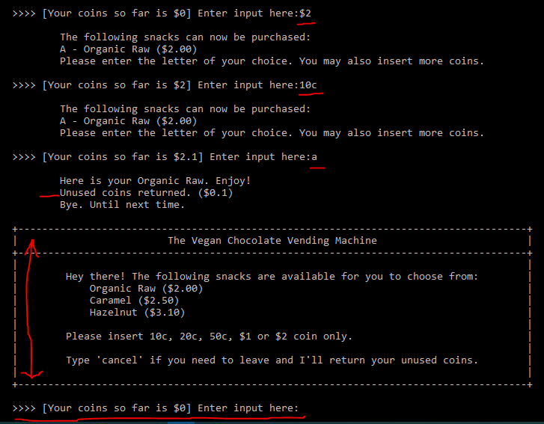

Step 4: Enter “$2” then “$1”.

Step 5: Enter “b” to select “Caramel” menu item.

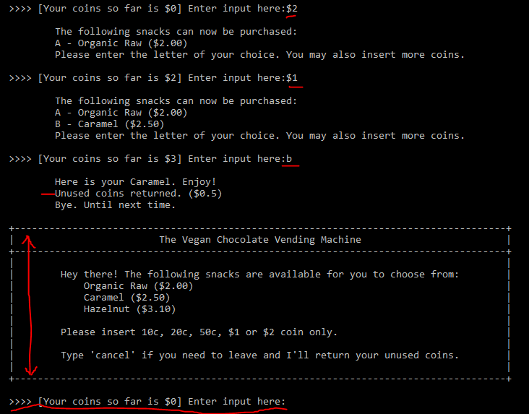

Step 6: Enter “$2” then “$2”.

Step 7: Enter “c” to select “Hazelnut” menu item.

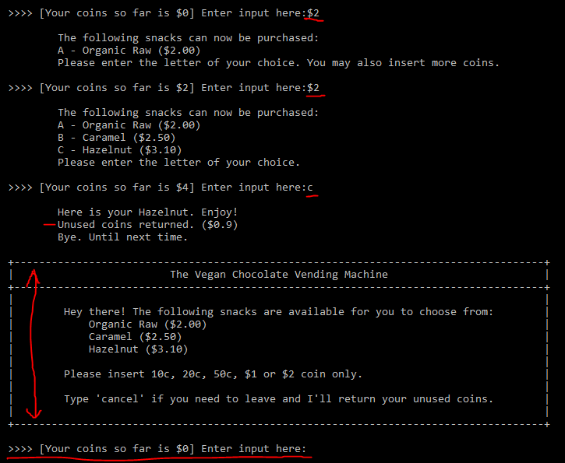

Result:

7.1 - The correct item is dispensed.

7.2 - The correct change is dispensed.

7.3 - The exit message is displayed.

7.4 - A new transaction is initiated. The heading and prompt with zero coins are displayed.

## Item # 8: User selects a menu item and the total inserted coins are less than the selected item price.

Step 1: Enter “10c” then enter “a”.

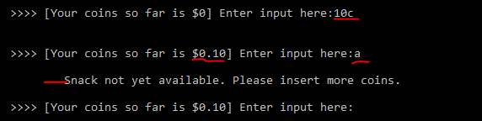

Step 2: Enter “$2” then enter “b”.

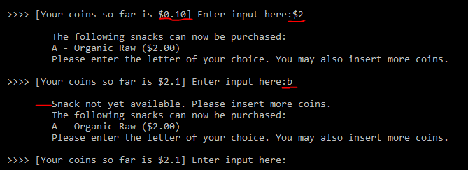

Step 3: Enter “50c” then “c”.

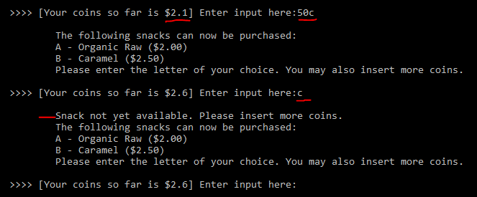

Result:

8.1 - The machine says that the menu item is not yet available and asks for more coins to be inserted.

8.2 - Menu items that can be purchased with the current coins are displayed.

## Item # 9: User cancels the transaction.

Step 1: Enter “cancel” when the total coin is zero.

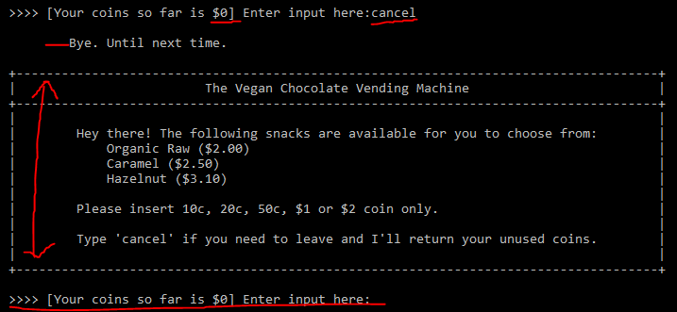

Step 2: Enter “10c”, “20c”, “50c”, “$1” then “$2”. Then enter “cancel”.

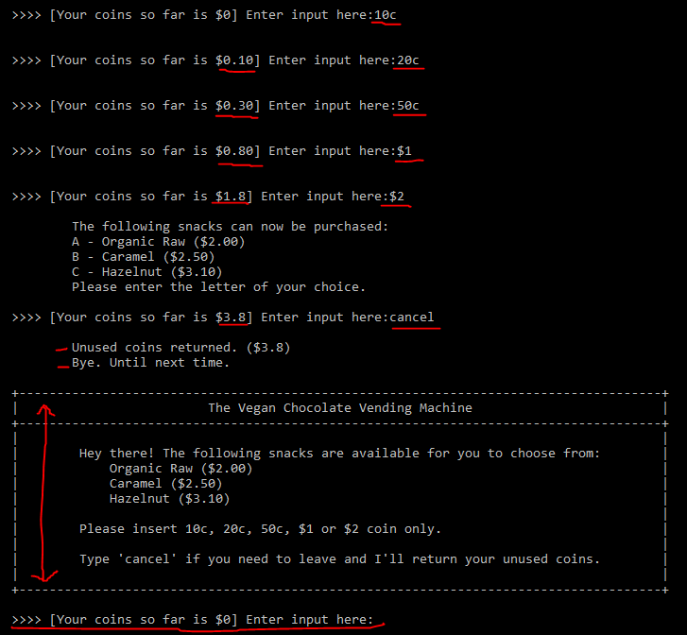

Result:

9.1 - Unused coins are correctly dispensed (if any).

9.2 - Exit message is displayed.

9.3 - New transaction is initiated. The heading and prompt with zero total coins are displayed.

## Item # 10: Application is terminated.

Step 1: Enter “terminate”.

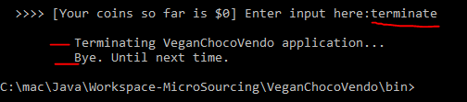

Step 2: Enter “java VeganChocoVendo” in the command prompt.

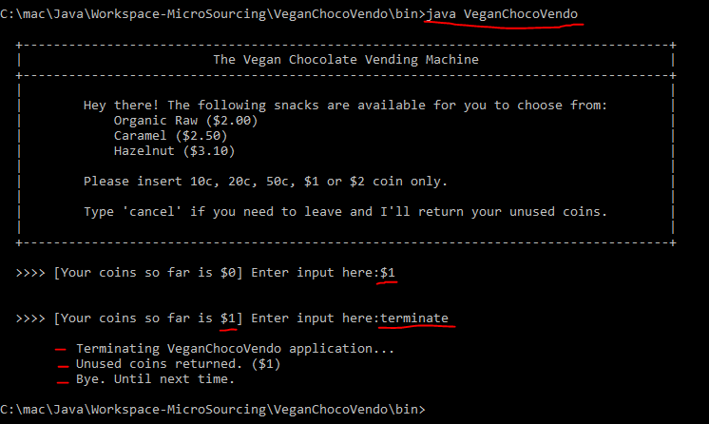

Results:

10.1 - Unused coins are dispensed correctly.

10.2 - Exit message is displayed.

10.3 - Application is terminated.